**Q1 : Using Insert Function, give examples of any function available in the different dropdowns present in the function library. For example AutoSum, Recently Used, Text, Date & Time, etc.**

1. **SUM** This function **adds** all the values of the cells in the argument
2. AVERAGE: This function determines the average of the values included in the argument. It calculates the sum of the cells and then divides that value by the number of cells in the argument.
3. COUNT: This function counts the number of cells with numerical data in the argument. This function is useful for quickly counting items in a cell range.
4. MAX: This function determines the highest cell value included in the argument.
5. MIN: This function determines the lowest cell value included in the argument.

**Q2 : What are the different ways you can select columns and rows?**

Ans : Ctrl + Space for columns. Shift + Space for rows.

**Q3 : What is AutoFit and why do we use it?**

Ans : AutoFit is a feature in Excel that lets you easily change the size of one or multiple columns or rows on a spreadsheet. It helps you make sure that all the data in every cell group is clearly visible.

**Q4 : How can you insert new rows and columns into the existing table?**

Ans : To add rows, click Insert Above or Insert Below and to add columns, click Insert Left or Insert Righ

**Q5 : How do you hide and unhide columns in excel?**

Ans : Select one or more columns, and then press Ctrl to select additional columns that aren't adjacent. Right-click the selected columns, and then select Hide.

**Q6 : Create an appropriate table within the worksheet and use different functions available in the AutoSum command.**

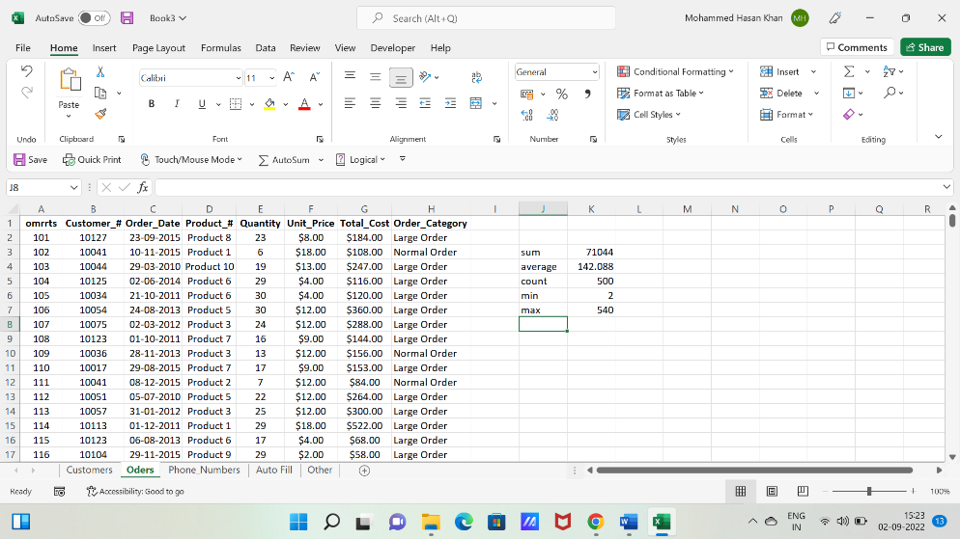Ans :